CO2 Data Loggers
This activity started as a result of a question about the legal position of encountering levels of CO2 in cave whilst at work. Asking the simple question of what levels were likely to be encountered revealed that while measurements had been made by people on caving trips no longer term information was available due to a lack of data loggers which were capable of recording data over weeks and months. A quick check revealed that there were sensors and circuits available based on the Arduino chip. So a simple breadboard circuit was made up and linked to a Non Dispersive Infra Red sensor capable of measuring CO2 levels up to 4%. The lash up was put in a sealable plastic food box with a lead to a sensor located outside the box and left in a cave over a long weekend, see figure 1. The recorded data showed an interesting feature, see figure 2, which encouraged me to seek help to make up a more capable circuit with reduced power demands. Help came in the form of Ian Cooper who not only rewrote the software to reduce power consumption by well over a factor of ten but also designed and built a miniature circuit to drive the sensor, see figure 3 & 4. This work has been reported in the CREG journal (1).
The first trials went well apart from ending for no apparent reason. So whilst work started to look for the bug, a watchdog routine was added to the software to ensure the program would not stall. The watchdog routine has been successful over months of testing though the original bug has yet to be identified. Work has also looked into the response times of the instrument. It was quickly recognised that there was a need to minimise the volume of air within the instrument which was shared with the sensor. Attempts to measure the response time were hampered by the considerable rate of diffusion of CO2 through ordinary plastic bags and cling film. (Cling film plus desiccant is favoured by some researchers as a means of keeping the humidity levels surrounding the sensor and instrument under control.) A suitable alternative was found with plastic vacuum storage bags (where one uses a vacuum cleaner to reduce the size of the bag and contents) which has a reasonably slow rate of diffusion. This area of study led to a theoretical investigation of response time behaviour which has also been published in the CREG journal (2). One notable feature brought out by that work is that the comparison of two instruments can be led astray if response times are not taken into account.
Unfortunately the development work with the sensor has not yet overcome the challenge of humidity. A first trial in Poole's Cavern was brought to a swift end due to humidity upsetting the instrument. A second trial worked for several weeks before succumbing to humidity. This work showed a reasonable relationship between our logger and another one deployed near bye, see figure 5. Work is now ongoing to isolate that part of the sensor which needs to be exposed from the rest of the sensor and ensure that the other parts of the sensor and the rest of the instrument are securely encased to eliminate the potential for water ingress.
Ref

- Carbon Dioxide Data Logging in Caves – Part 1, B Mehew, CREG Journal 104 p18-19; http://bcra.org.uk/pub/docs/downloads.html?f=j104018 , and
Carbon Dioxide Data Logging in Caves – Part 2, B Mehew & I Cooper, CREG Journal 106, p7-10; http://bcra.org.uk/pub/docs/downloads.html?f=j106007 .

- Response Characteristics of Instruments and Sensors, B Mehew, CREG Journal 107 p11-12; http://bcra.org.uk/pub/docs/downloads.html?f=j107011 .

Figures

Fig 1

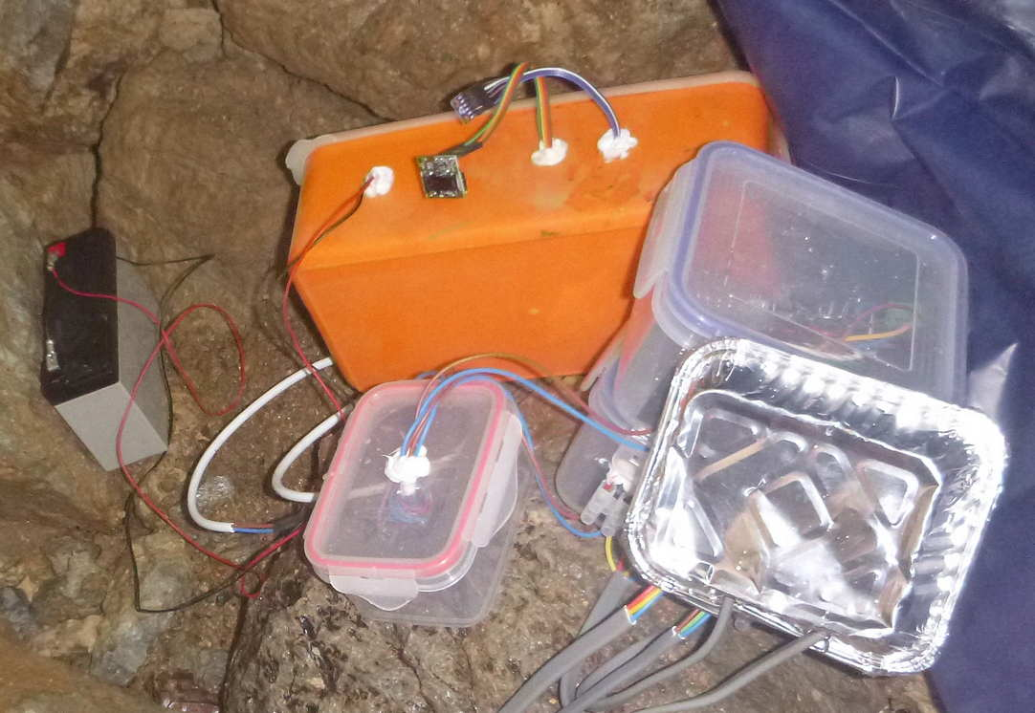

The orange plastic food box contained the bread board with the CO2 sensor in front of it and a pressure / temperature sensor above it. (The other plastic boxes and aluminium food tray were part of a separate experiment.)

Fig 2

Note sample frequency was every 20 seconds so the event at 400 minutes of a rise in CO2 concentration of over 300ppm occurred within 4 minutes. (The sensor had not been calibrated.)

Fig 3

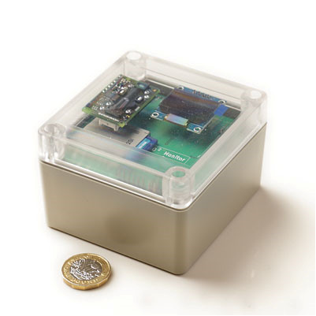

Micro electronic version within sealable box. (The isolation of the sensor in the top left of the box is not shown.)

Fig 4

I don’t have an image of the instrument in Poole’s cavern but do have one elsewhere

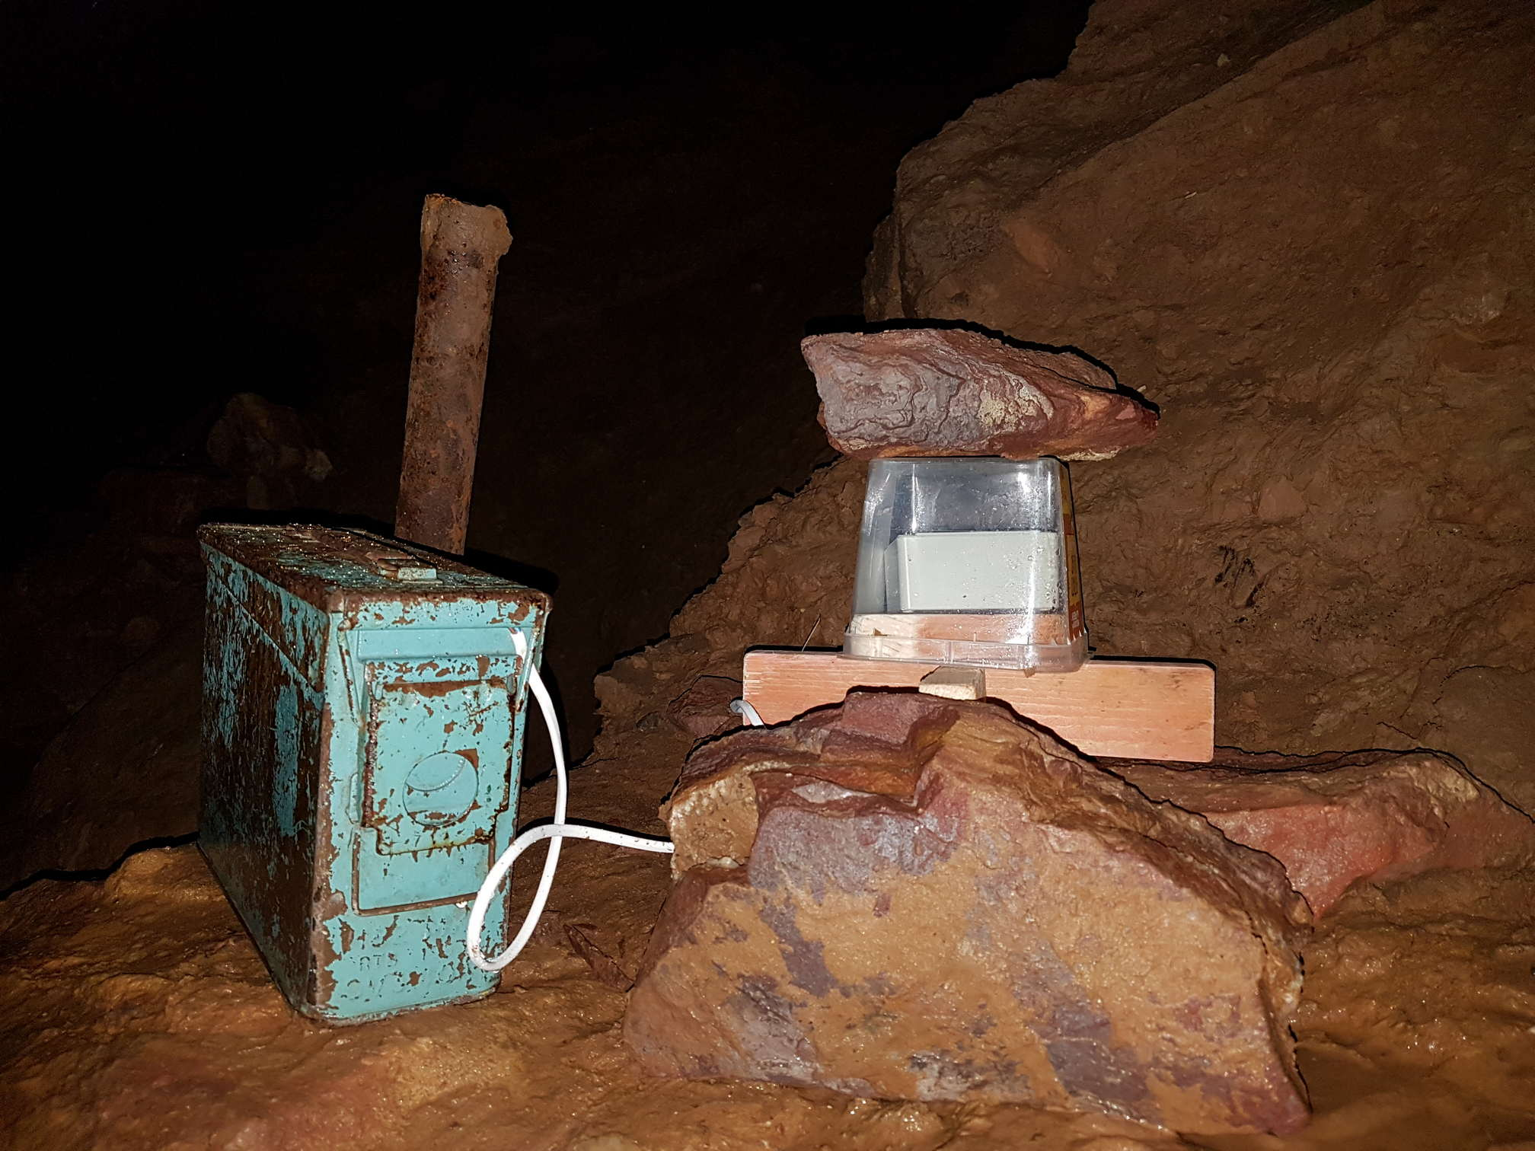

The instrument is placed under a plastic box with open ventilation from below. The 12v battery source is in the amo can.

Fig 5

The logger 1 plot reflects a sampling interval of 5 minutes against 30 minutes for logger 2. There is also an apparent lag between the two plots probably due to non-synchronisation of the timing devices.

